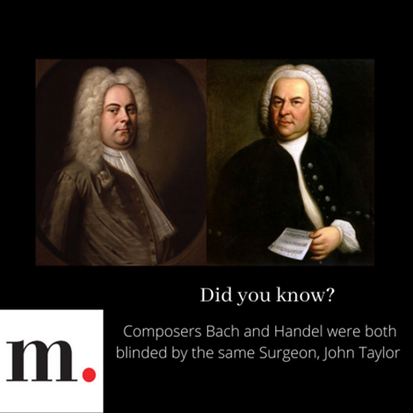
DID YOU KNOW?

Your _____ library card gives you access to the biggest and best online collection of operas, ballets, concerts, and more all for free?

